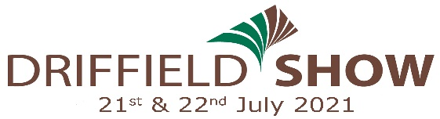
Post entries to: Mrs J Jenkinson, Livestock Secretary
Driffield Showground, Kelleythorpe,
Driffield, East Yorkshire. YO25 9DN.
Or email to: office@driffieldshowground.co.uk

r

SHEEP SECTION ENTRY FORM
* Entrants are requested to note the day their respective classes take place on*
**All contact details must be completed for track and trace purposes**
OFFICE USE | CLASS NO. | BREED | SHEEP HEALTH  SCHEME Y/N | DATE OF BIRTH | ENTRY FEE
Name …………………………………………………………………………………………………………………………..  Address ……………………………………………………………………………………………………………………….  …………………………………………………….. Post Code …………………………………………………………..  Email …………………………………………………………………………………………………………………………..  Telephone No ……………………………………………………………………………………………………………. |  |  |  | FEES
 |  |  |  | Membership @ £40
 |  |  |  | Programmes@ £3.50
 |  |  |  | TOTAL
Please indicate
number of
pens required
BACS: Use your name as reference for identification purposes and tick below to indicate you are using this payment method.
Sort Code: 60.07.05 Account No: 40110265 …………….. (tick)
Payment by DEBIT/CREDIT CARD (unfortunately we are unable to accept American Express)
Card No

Expiry Date Start Date

Issue No Security No

ENTRIES CLOSE FIRST POST 21ST JUNE, 2021 – ALL ENTRY FEES MUST ACCOMPANY THIS FORM

NOTE: The certificate of MV/CAE status-accredited flock must be presented to the Sheep Steward before the sheep are unloaded
Entry fees in excess of £20 will receive an additional ticket. Exhibitors will receive 2 admission tickets for each section entered. Extra tickets may be purchased from www.driffieldshowground.co.uk. Please enclosed a stamped addressed envelope if you require confirmation of your entry.
Late entries accepted at the discretion of the Livestock Secretary.
Each exhibitor shall be solely responsible for any consequential or other loss, injury or damage done to or occasioned by, or arising from any animal or article exhibited by them, and for its description given in the catalogue, and shall and indemnify the Secretary and Society Officers and Servants against all legal or other proceedings in regard thereto. Completion of this entry form acknowledges the exhibitors agreement to abide by and accept all terms and conditions of the Driffield Show as laid out in the Show Regulations in the Livestock Schedule.

