All completed entry forms to :- THE LIVESTOCK SECRETARY,  Mrs J Jenkinson, Driffield Showground, Kelleythorpe,  Driffield, East Yorkshire, YO25 9DN  Or email to: office@driffieldshowground.co.uk  PLEASE WRITE CLEARLY IN BLOCK CAPITALS |  |  |  |  |  |  |  | 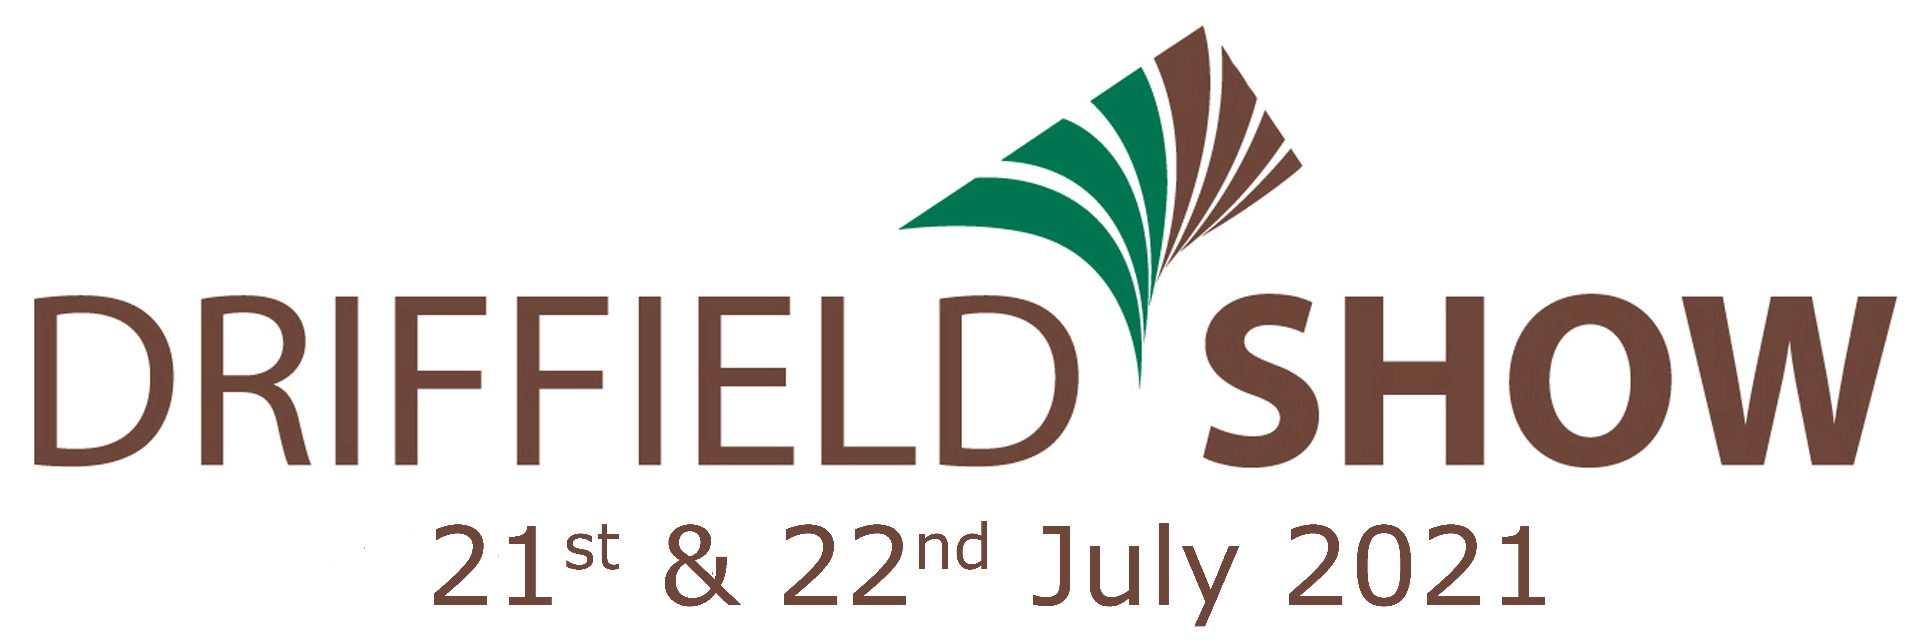  ENTRY FORM – CATTLE SECTION  * Entrants are requested to note the day their respective classes take place on*  **All contact details must be completed for track and trace purposes**

In aid of
FOR OFFICE USE |  | CLASS No |  |  | BREED | Name of Animal | Herd Book Passport No | Ear No | Date of Birth | Date of last calving | Name & No of Sire | Sire’s Herd Book | ENTRY FEE
Name
Address |  |  |  |  |  |  |  |  |  | FEES
 |  |  |  |  |  |  | Post Code |  |  | Membership @ £40 each
Email |  |  |  |  |  |  | Phone No |  |  | Programmes @ £3.50 each
BACS: Use your name as reference for identification purposes and tick below to indicate you are using this payment method.
Sort Code: 60.07.05 Account No: 40110265 ………….. (tick)
Payment by DEBIT/CREDIT CARD (unfortunately we are unable to accept American Express) |  |  |  |  |  |  |  |  | ENTRIES CLOSE FIRST POST 21st JUNE 2021
Card No |  |  |  |  |  |  | Expiry |  | ALL ENTRY FEES MUST ACCOMPANY THIS FORM  Entry Fees in excess of £20 will receive an additional ticket.  Exhibitors will receive 2 admission tickets for each section entered.  Extra tickets may be purchased from www.driffieldshowground.co.uk  Late entries accepted only at the discretion of the Livestock Secretary.
Issue No |  |  |  |  | Security No |  | Start
PLEASE ENCLOSE A STAMPED ADDRESSED ENVELOPE IF YOU REQUIRE CONFIRMATION OF YOUR ENTRY.
Each exhibitor shall be solely responsible for any consequential or other loss, injury or damage done to or occasioned by, or arising from any animal or article exhibited by them, and for its description given in the catalogue, and shall and indemnify the Secretary and Society Officers and Servants against all legal or other proceedings in regard thereto.
Completion of this entry form acknowledges the exhibitors agreement to abide by and accept all terms and conditions of the Driffield Show as laid out in the Show Regulations in the Livestock Schedule.

